9th April, 2024

|  |  |
| --- | --- |
| **Members** | **Roll numbers** |
| 1. Jawad Hassan (AI) | 2230-0035 |
| 1. Rizwan ul Hassan (CYS) | 2330-0135 |
| 1. Muhammad Talha Ramzan (AI) | 2330-0141 |
| 1. Usman Aslam (AI) | 2330-0150 |
| 1. Adil Khan (AI) | 2330-0030 |
| 1. Taha Malik (CYS) | 2330-0156 |



Team: CASE Dev

**Project Title: Karyana Mart Sales and Inventory Management System**

Requirement & Specification Document

**Submitted to: Dr. Shafaat A. Bazaz**

Table of Contents

Preface2

Introduction3

Glossary4

Team Details5

Meetings6

Specification Process7

Prototype of UI 8

Contract9

Elicitation10

Analysis14

Problems and Issues15

Interviews21

User Stories24

Natural Language26

Structured Language31

User and System Requirement32

Functional 33

Non- Functional34

Test Cases35

Graphical Notation37

Requirements Validation40

Index41

Preface

This Software Requirement Analysis and Specification with System Specification document has been prepared by the students of CASE Islamabad as part of the undergraduate Software Engineering course. The document is intended to provide a comprehensive analysis and specification for an Inventory and Sales Point of Sale (POS) system for Karyana Store, a fictional retail store.

The development of this document involved a thorough understanding of the requirements and needs of Karyana Store, as well as the application of software engineering principles and methodologies learned during the course. The document includes detailed descriptions of the functional and non-functional requirements of the POS system, along with use cases, system architecture, and user interface design.

The purpose of this document is to serve as a guideline for the development team at Karyana Store and provide a clear roadmap for the implementation of the POS system. It is our hope that this document will contribute to the successful development and deployment of the system, meeting the needs and expectations of Karyana Store.

We would like to express our gratitude to our instructors and mentors for their guidance and support throughout the development of this document. We also extend our thanks to Karyana Store for providing us with the opportunity to work on this project and gain valuable real-world experience in software engineering.

Students of CASE Islamabad

[Students]

1. Jawad Hassan
2. Rizwan ul Hassan
3. Muhammad Talha Ramzan
4. Usman Aslam
5. Adil Khan
6. Taha Malik

[Software Engineering]

[9 April, 2024]

Introduction

Karyana Store, a prominent retail establishment, is in need of a modern Inventory and Sales Point of Sale (POS) system to streamline its operations and enhance customer service. The current manual system is inefficient and prone to errors, leading to inventory discrepancies and customer dissatisfaction. To address these challenges, the students of CASE Islamabad have undertaken the task of developing a comprehensive software solution that meets the specific needs of Karyana Store.

This document serves as a detailed analysis and specification for the proposed POS system. It outlines the functional and non-functional requirements, use cases, system architecture, and user interface design. The goal is to provide a clear understanding of the system's scope and capabilities, ensuring that it aligns with the expectations and requirements of Karyana Store.

The development of this document follows the principles and methodologies of software engineering taught in our undergraduate course. It represents our commitment to applying theoretical knowledge to practical, real-world scenarios, and showcases our ability to deliver high-quality software solutions.

We believe that the proposed POS system will significantly improve the efficiency of Karyana Store's operations, leading to better inventory management, accurate sales tracking, and ultimately, improved customer satisfaction. We are excited about the opportunity to work on this project and look forward to seeing the positive impact it will have on Karyana Store's business

Glossary

POS (Point of Sale): The point at which a retail transaction is completed. It is the point at which a customer makes a payment to the merchant in exchange for goods or services.

FMCG (Fast-Moving Consumer Goods): Products that are sold quickly and at a relatively low cost. Examples include food and beverages, toiletries, and other consumables.

GT (General Trade): The traditional distribution channel in which goods are sold from manufacturers to wholesalers to retailers, as opposed to modern trade channels such as supermarkets and hypermarkets.

Inventory Management: The process of efficiently overseeing the constant flow of goods into and out of an existing inventory.

Sales Tracking: The process of monitoring and analyzing sales performance to identify trends, forecast future sales, and make informed business decisions.

Barcode Scanning: The use of a barcode reader to scan and read barcodes on products, enabling quick and accurate tracking of inventory and sales.

Payment Gateway: A service that processes credit card payments for online and traditional brick-and-mortar stores, securely transmitting payment information between the customer and the merchant.

Retail Store: A place of business that sells goods directly to consumers, typically in small quantities for personal or household use.

UML (Unified Modeling Language): A standardized modeling language used to visualize, specify, construct, and document the artifacts of a software-intensive system. UML offers a standard way to visualize a system's architectural blueprints, including elements such as activities, actors, business processes, database schemas, components, and interfaces.

**Semester Project**

**Project Report and Specification Document:**

**Report:**

**Q. What is the Project?**

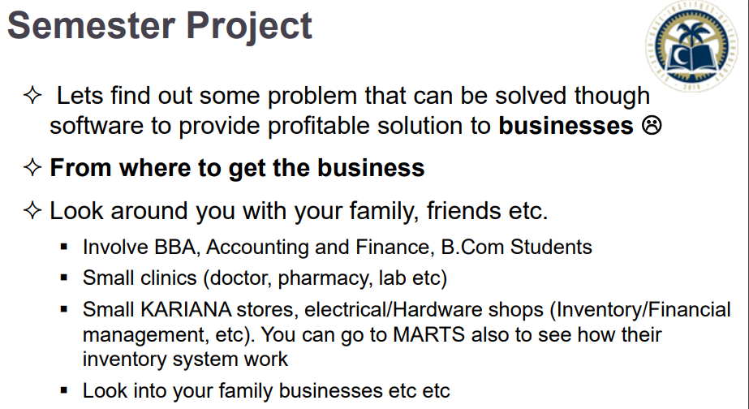

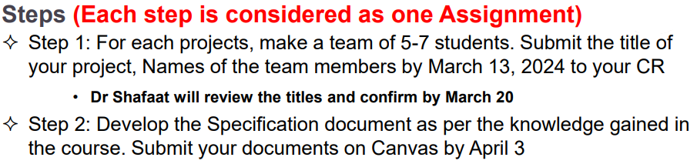

**Step 2 -Submission deadline:**

9th April, 2024

**Our Team Members:**

Total Members: 6 (not more than 7, perfectly makes a scrum team)

|  |  |
| --- | --- |
| **Members** | **Roll numbers** |
| 1. Jawad Hassan (AI) | 2230-0035 |
| 1. Rizwan ul Hassan (CYS) | 2330-0135 |
| 1. Muhammad Talha Ramzan (AI) | 2330-0141 |
| 1. Usman Aslam (AI) | 2330-0150 |
| 1. Adil Khan (AI) | 2330-0030 |
| 1. Taha Malik (CYS) | 2330-0156 |

Our Company Name: CASE Dev.

**What and why is our Project?**

Project goal: In family, friends or known person should be client (keyword)

Project Title: **Karyana Mart Sales and Inventory Management System**

Project need: The reason we chose this project, as mentioned by Sir, the **CLIENT**has to be related to us somehow.

**Project’s 1st Meeting Key point (19th March, 2024):**

* 1. **Professional Discussion Software:**

Discord:

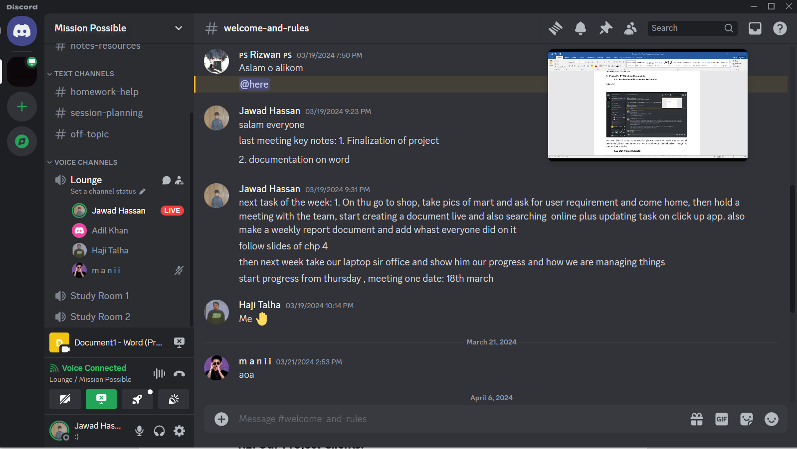

We used discord as our communication platform where we made a server and all teammates joined that server and we a used voice channel called ‘Lounge’ to communicate via voice.

* 1. **Our Project Potential Clients:**

After team discussion we figured out that in total we have 3 clients with commonality in Kariana Stores which makes up a perfect project as Sir mentioned that it could be a Kariana store.

|  |  |  |
| --- | --- | --- |
| **Member Name** | **Association with Client** | **Store Name** |
| Jawad Hassan | Friend’s Store | Hameed Kariana |
| Rizwan ul Hassan | Father’s Store | Adnan General Store |
| Muhammad Talha Ramzan | Cousin’s Store | Hunain Karyana Store |

**Project’s 2nd Meeting Key point (6th April, 2024):**

Roles assigned:

* Jawad Hassan – Software Interface Prototype/ UI design, Ethnography (Social Science) , Business Developer and Formal Interviewer(Questionnaires)
* Rizwan ul Hassan and and Usman Aslam- User Story and Scenario
* Muhammad Talha Ramzan – Raw Data Elicitation, Analysis and Natural Language Specification
* Adil Khan – User Case UML design diagram and Flowcharts
* Taha Malik - Tasks cards from user stories

Task deadline: Must be done by 8th of April

**Specification Process:**

**Requirement Engineering Techniques:**

From now own all the further documentation will be done by following our software engineering chapter 4 **Requirement Engineering** slides.

Slides Fact checking: Adil Khan

**Spiral Model Followed:**

We tried our best to follow the basic steps of spiral model for Requirement Specification:

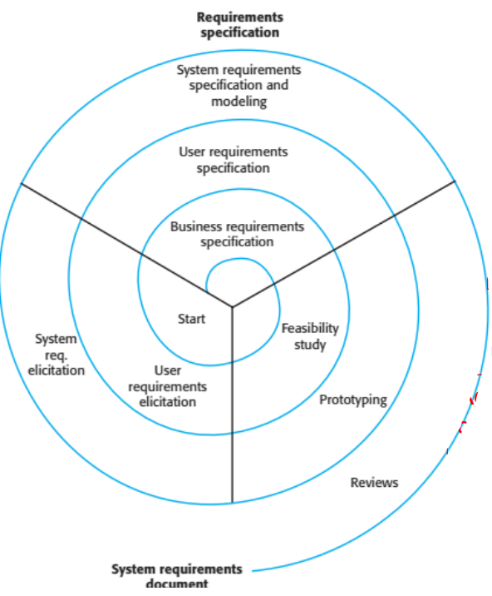

**What does our clients demand from software?**

A simple easy to use software for karyana store which should be able to store product’s data (Inventory), maintain and manage Sales and Customer Information and increase profit sales by generating reports.

1. **Requirements :**

**1.1 Abstract User Requirements for Bidding Phase in order to win Contract:**

* An easy way for users to easily use the software.
* The software should be able to easily store data.
* There should be a login system with a password for client (shop owner) privacy.
* Personal shop profit data should be secure and only accessible by the owner.
* It must track the stock from wholesalers and have their contact info.
* It must report sales at end of month and highlight products in profit.
  1. **Prototype in form of Potential software Interface layout (UI/UX design)**

Made on Canva by Jawad Hassan

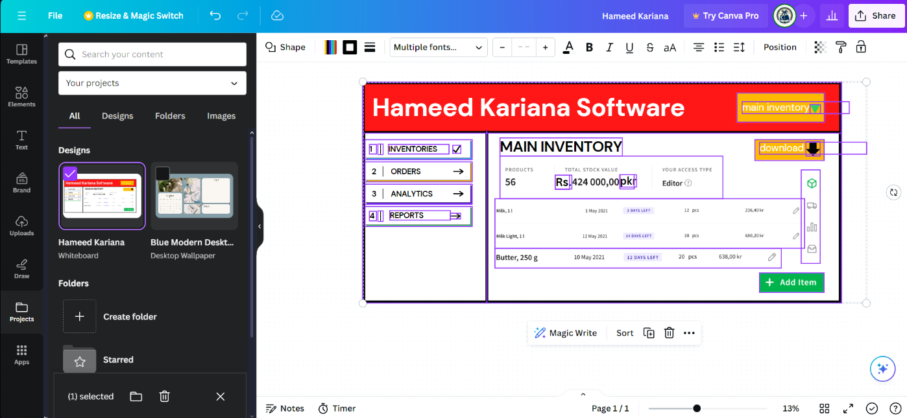

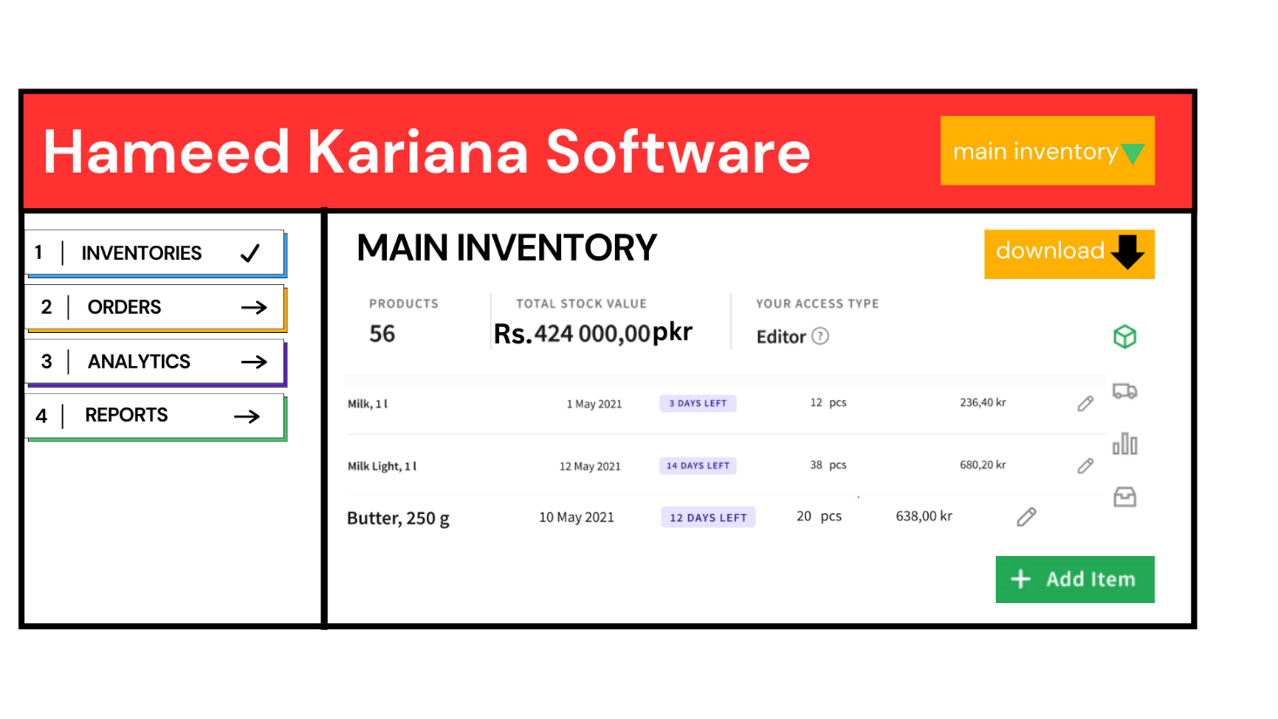

**Agreement/ Contract for Kariana Mart Sales and Inventory Management System**

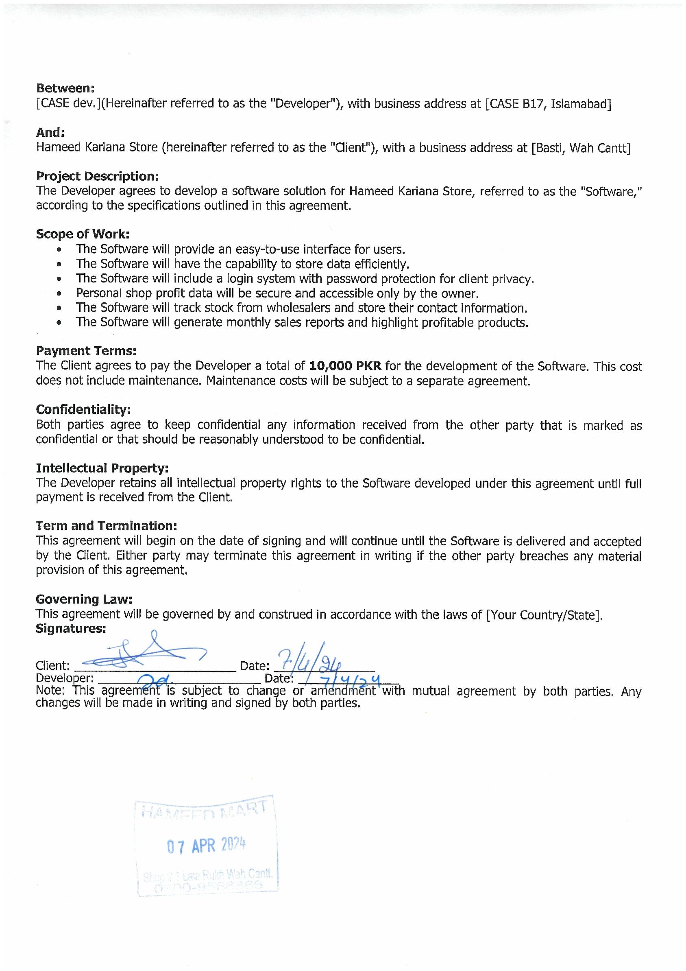

**Detailed Requirements after Winning the Contract by following**

**Requirement Engineering Process**

* 1. **Elicitation and Analysis**
  2. **Requirements discovery and understanding**
     1. **Elicitation Techniques**

**Focused Ethnography (observation):**

**Huge Scale Example Marts (Model Softwares) for Review and Understanding:**

-by Jawad Hassan

1. **CSD Mart:**

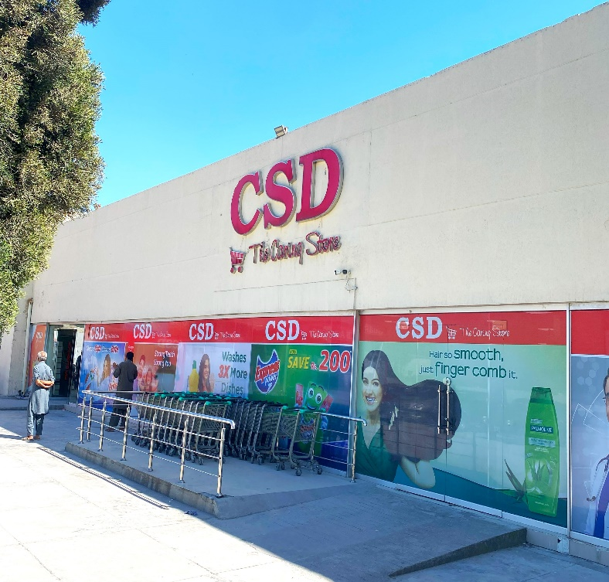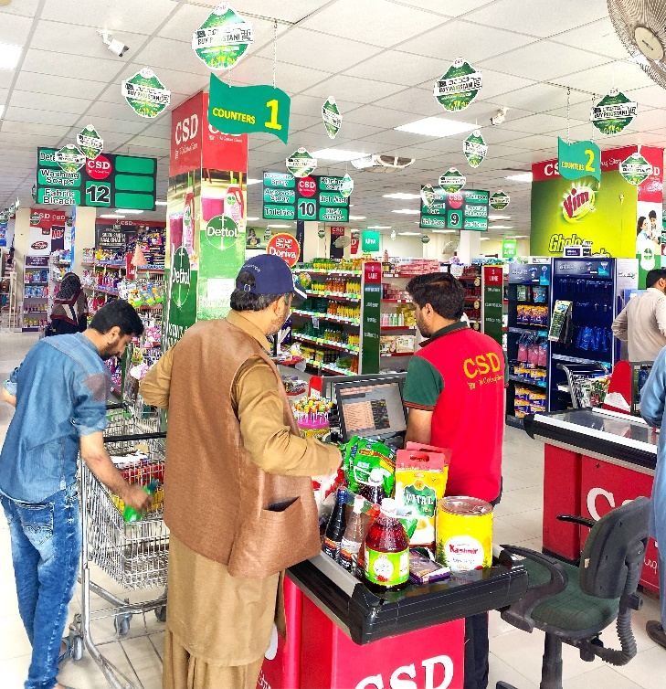

**Confidentiality:**

Due to it being under armed forces organization we respected their policy of not taking picture of their sensitive data however we were allowed to note down the gathered data

**Raw Data:**

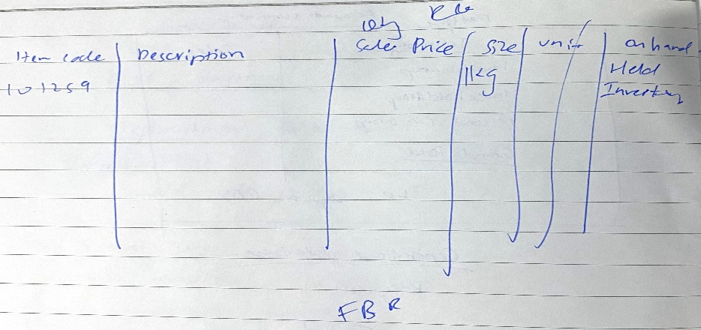

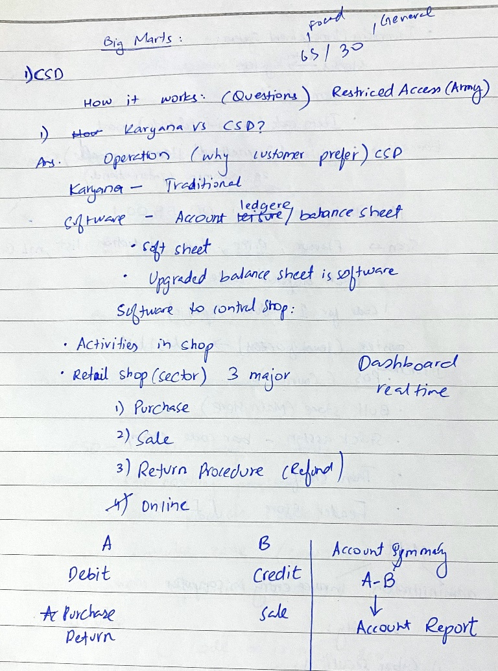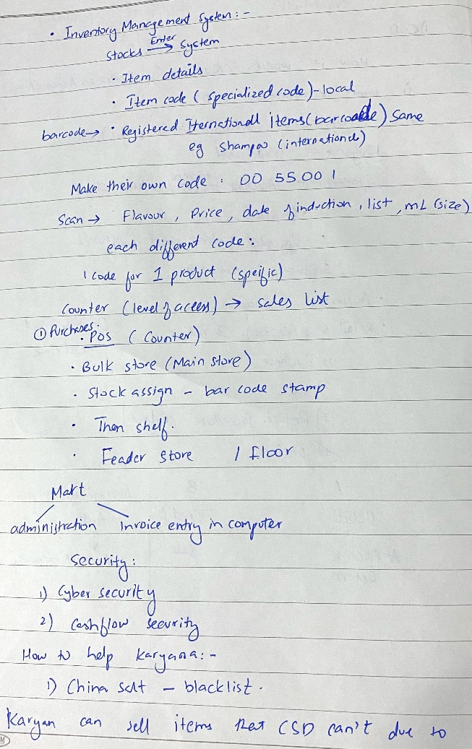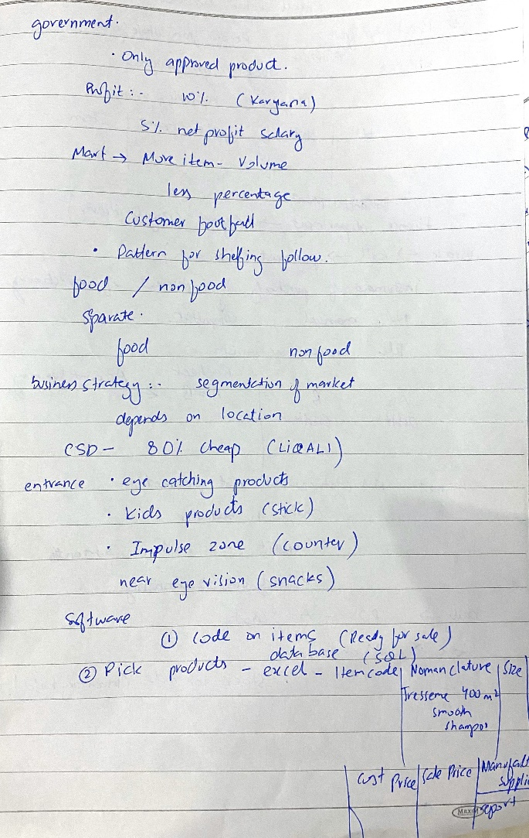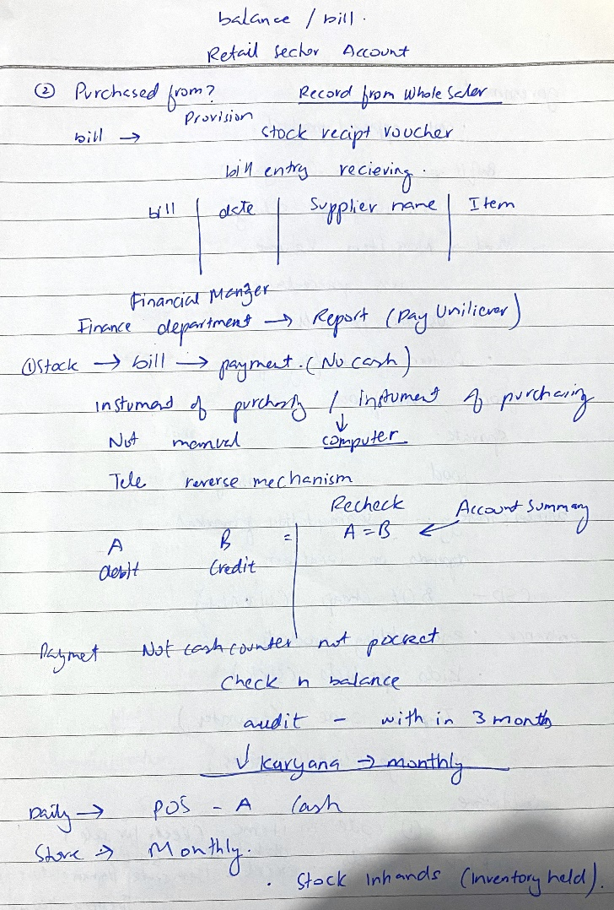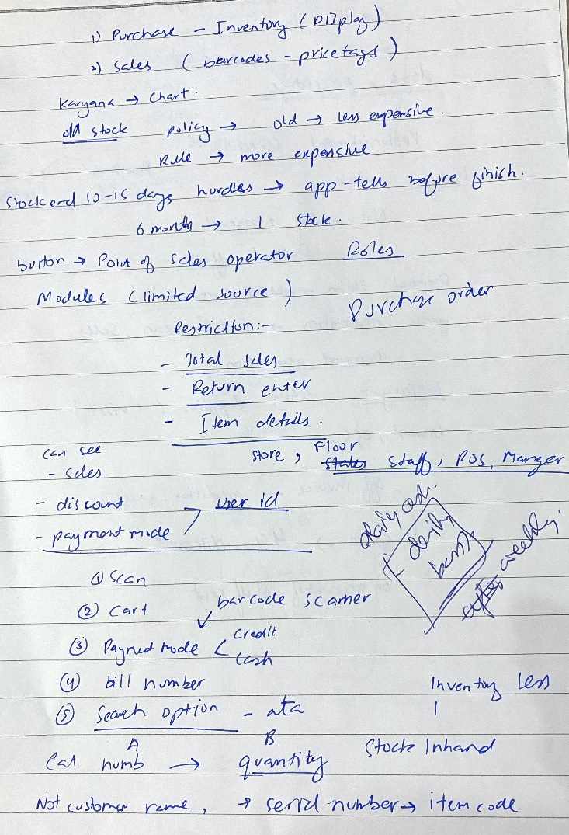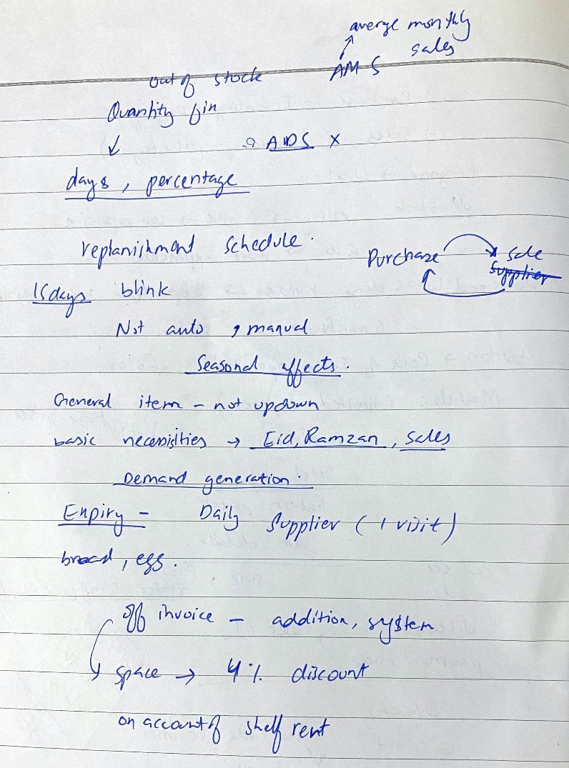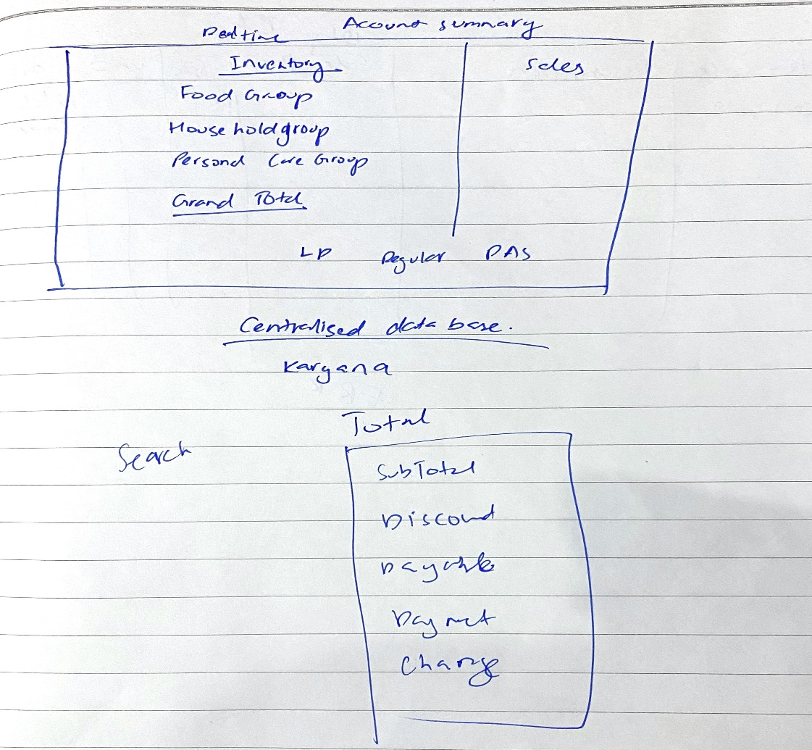

1. **Shaheen Cosmetics:**

We were allowed to take pictures of their system, software and aisles:

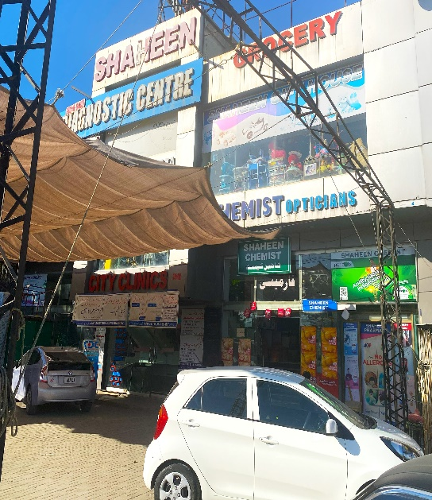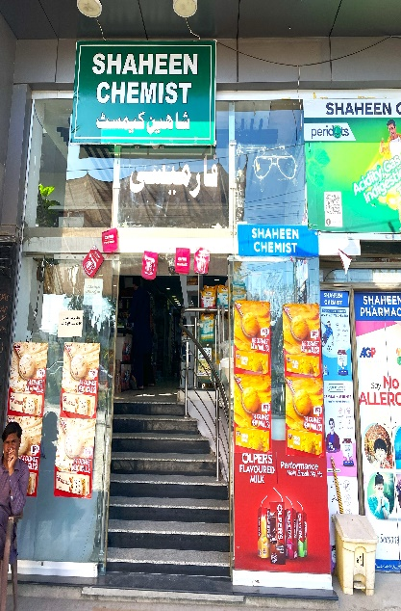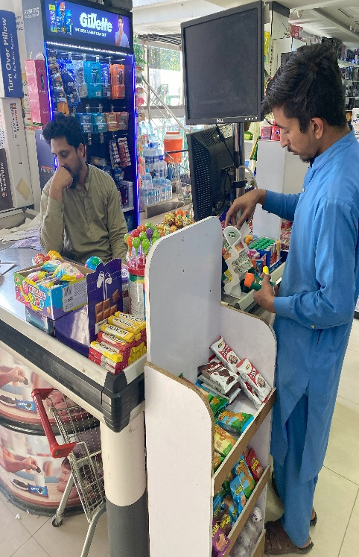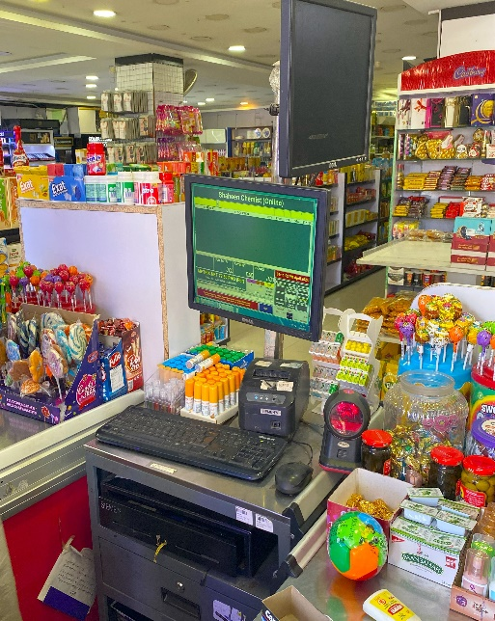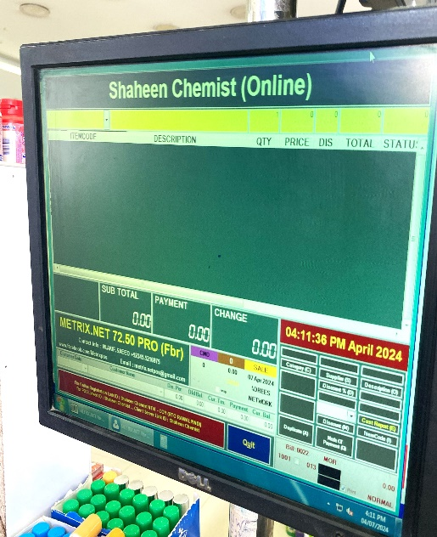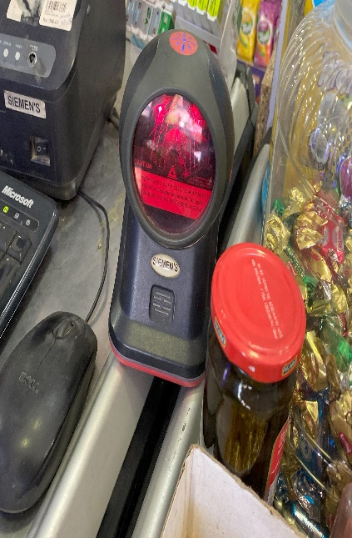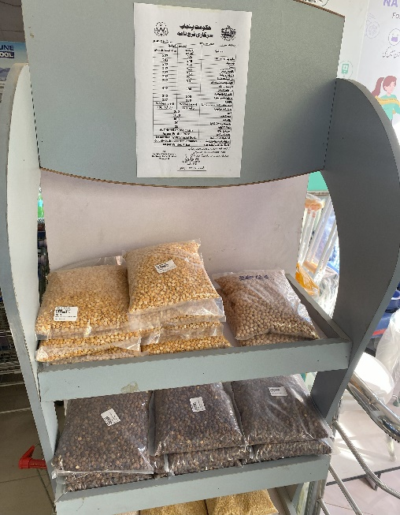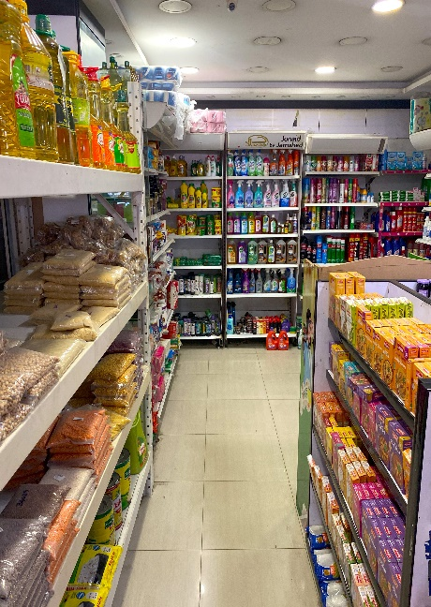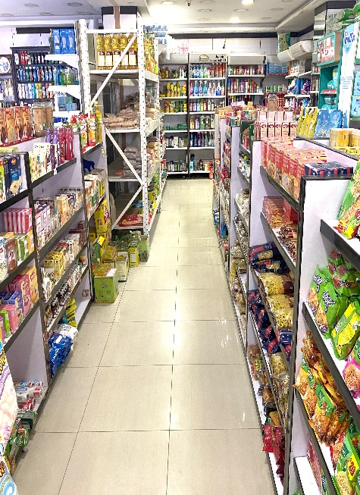

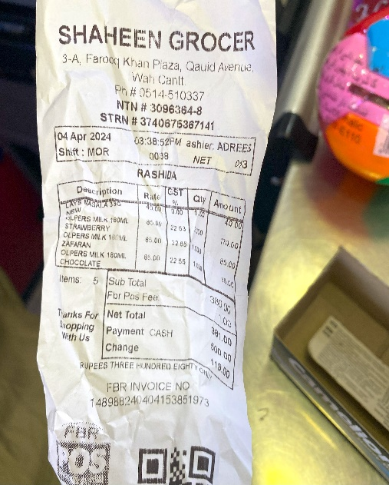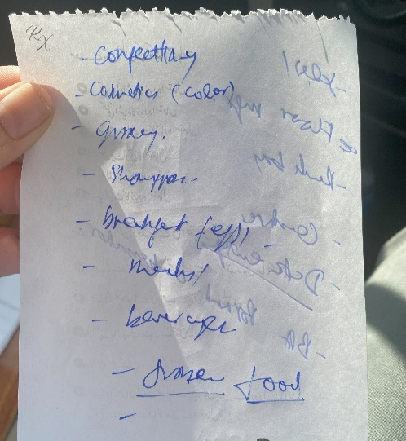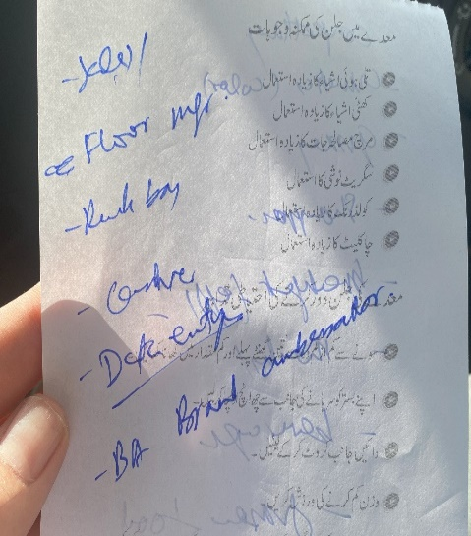

**Example Software (Inventory):**

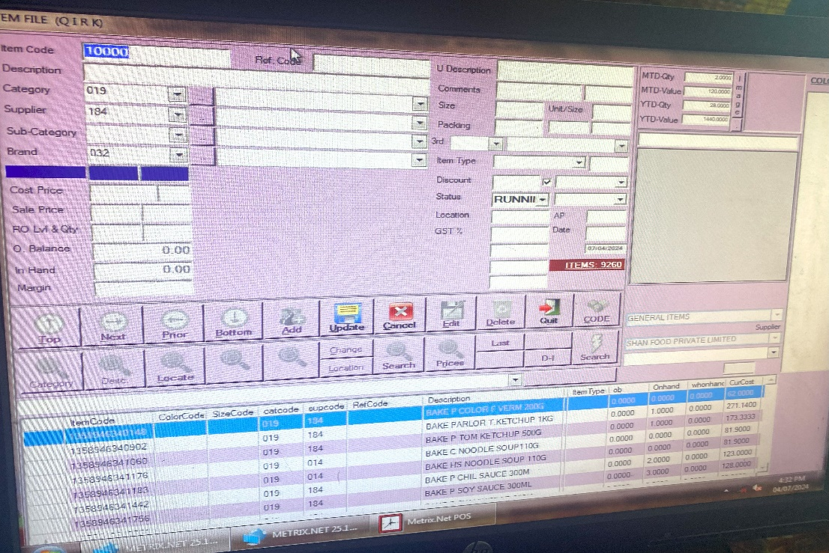

**1.1.2 Analysis:**

**Some Key points learnt from these big marts to increase profit:**

* 1. Software should control marts by creating Account ledger/ Balance sheet
  2. Catering for Seasonal effects and Off-invoice shelf rent implementation
  3. 3 activities in marts(Retail Store):
     1. Purchase (whole sellers)
     2. Sale (cutomers)
     3. Return (Refund)
  4. Account summary (debit = credit )
     1. At end of month
     2. At end of day
  5. Inventory management system, every item has its own shop or international barcode
  6. Karyana can add blacklist items that big marts cannot eg. China Salt
  7. Have eye catching impulse zone near cashier, discounts on most demanded/ old stock

**Main Targeted client Mart:**

* Hameed Kariana Mart

**Satellite Map location:**

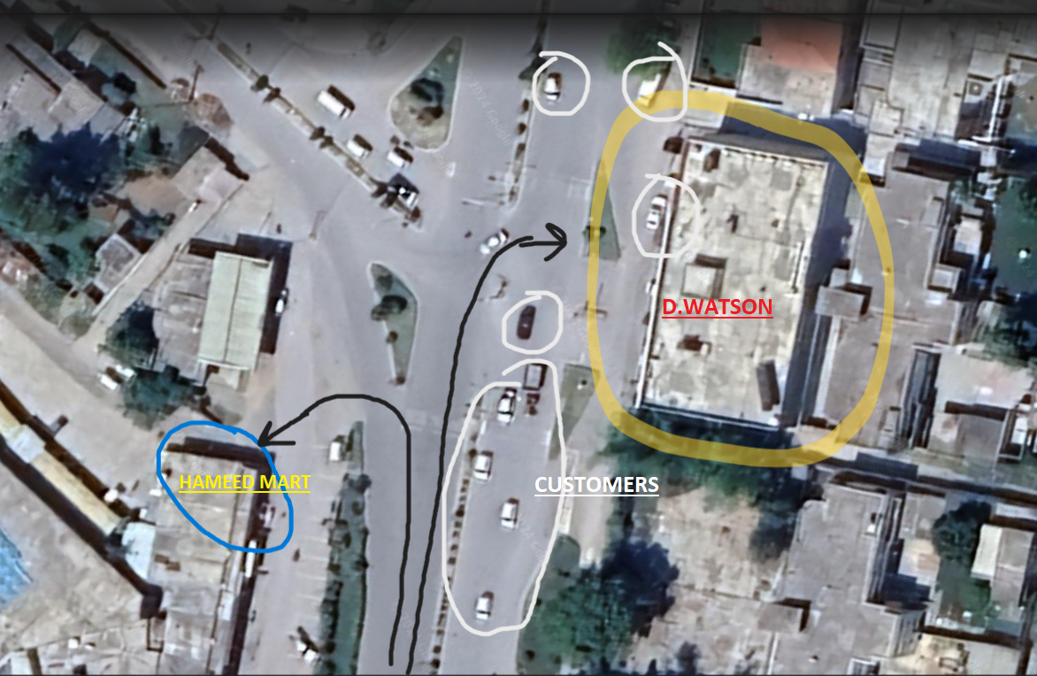

**Fig.1**

**Entrance View:**

|  |  |
| --- | --- |
|  |  |

**Positive Selling Points:**

1. Location is corner and near traffic signal stop
2. Eye catching products at entrance for kids
3. Discount rack at the entrance
4. Variety and quality of items with reasonable price
5. This is a General trade store consisting of Fast-moving consumer goods

**Inside View:**

|  |  |  |
| --- | --- | --- |
|  |  |  |
|  |  |  |

**Mart own product series (Branching out):**

Different types of dates:

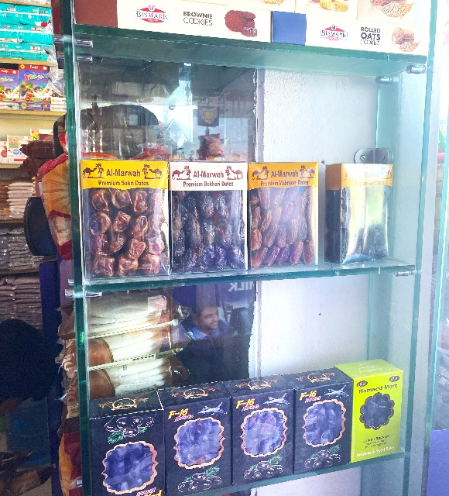

**Types of Aisles:**

These are different types of aisles present in the karyana sequentially:

|  |  |  |
| --- | --- | --- |
| #1 Frozen items & Cold Beverages | #2 Breakfast items |  |

|  |  |  |
| --- | --- | --- |
| #3 Drink items |  | #4 Dairy Products |
| #5 Canned/ Confectionery |  |  |

|  |  |  |
| --- | --- | --- |
| #6 Staple Food |  |  |

**Shelving Pattern followed according to Customer Footfall:**

One thing I really liked is that the kariyana knew hot drink item like tea is sold more than coffee/ green tea so it is placed on the customer eye level as shown in figure below:

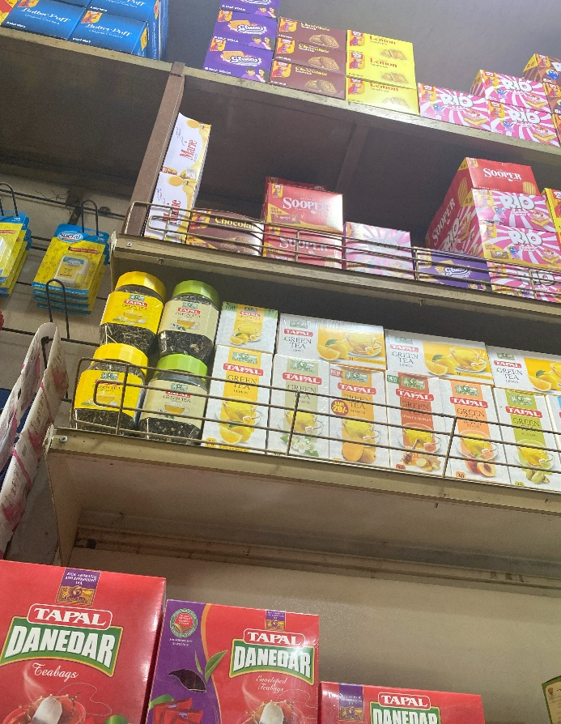

**Back (Inventory store) store:**

It contains all the fast moving extra items received from the whole seller

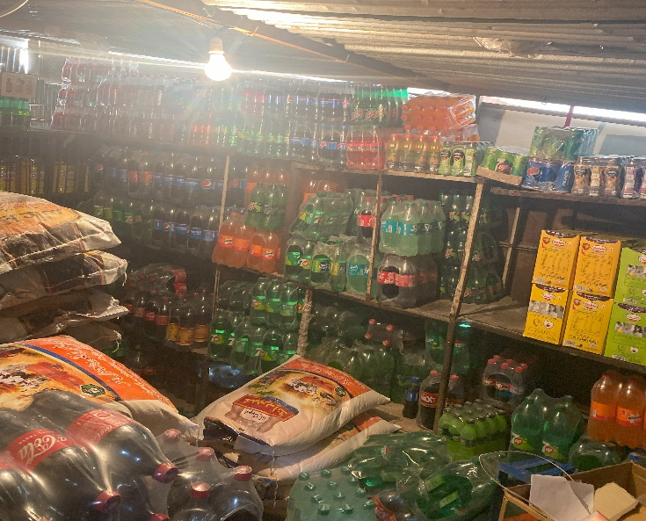

**Problem and Issues/ (Reason for software):**

The clients (shop owner of Hameed mart and other stores) are all worried due to the fact that most of their customers are being driven away from small karyana marts and are preferring big marts like D.watson as shown in above Fig 1. Aerial view white circle.

**Current trend:**

Usually these days our clients are filling in data on registers and using old school methods which causes delay in sales and makes the customer fed up due to inconvenience. So customer prefers big marts.

**Issues:**

1. **Manual Record Keeping (Register Based)**

It creates confusion, loss of previous data, difficulty in searching, tracking and predicting future purchase requirements. Our software will replace following two registers:

* 1. Purchases from Whole seller
  2. Daily sales Record

As shown in following figure:

|  |  |  |
| --- | --- | --- |
|  |  |  |

1. **No Standardized Item Codes**

|  |  |  |  |
| --- | --- | --- | --- |
| 1. **Barcode** | 1. **Shop 3 digit code** | 1. **Prices instead** | 1. **Unlabeled** |

Not using one system of standardized code creates confusion in tracking inventory but karyana uses 4 codes:

1. **Uncategorized item placement on aisle:**

Due to non-standard placement of some items, Customers cannot trace the item, it causes waiting ques and delays in payments at cash counter and errors in billing.

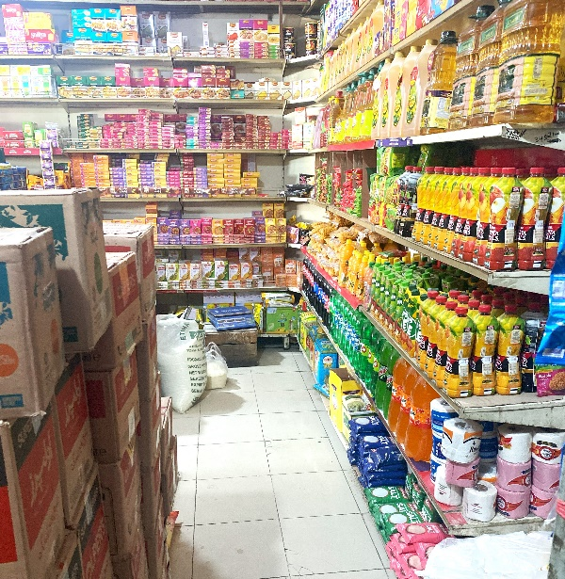

* **Hunain Karyana Store:** -by Muhammad Talha Ramzan

**Store’s Raw Data (Receipts):**

These are some manual receipts and bills elicitation:

|  |  |  |  |
| --- | --- | --- | --- |
|  |  |  |  |

|  |  |  |
| --- | --- | --- |
|  |  |  |

**Solution (why):**

We went to observe different big marts such as CSD and Shaheen Mart, collected their data, viewed their inventory software and figured out the reason why customers are driven towards these marts instead. We will use these software engineering tools and techniques to create a system for our clients that will solve this arising problem and help them manage their product sales, inventory and thus gain more profit.

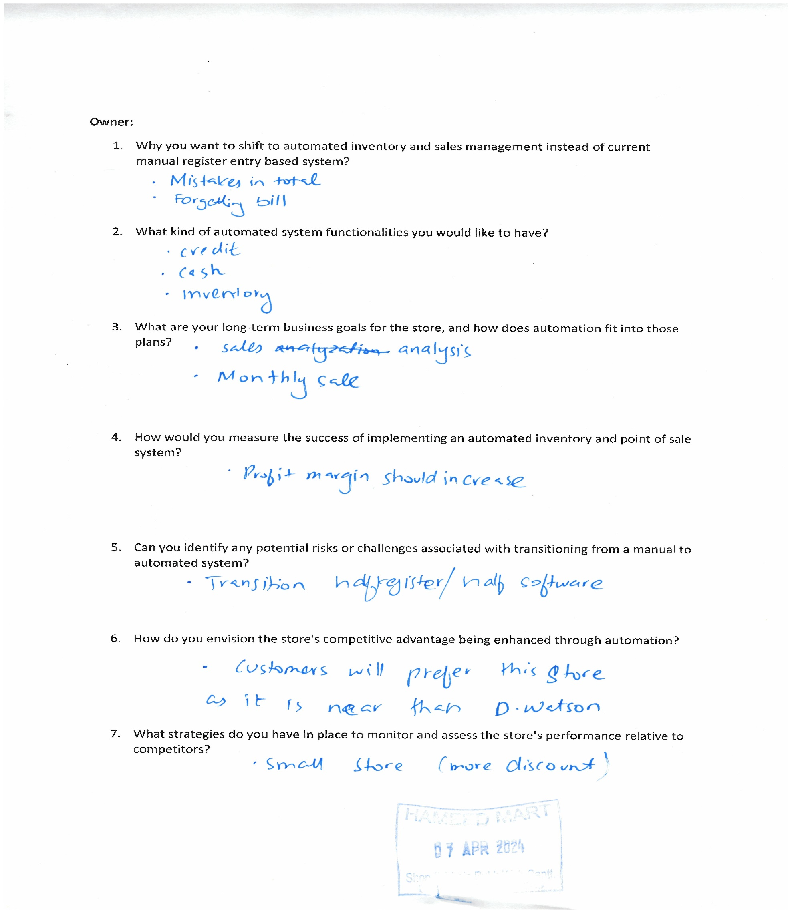**Effective Formal Interviewing Questionnaires (Closed) -** By Jawad Hassan

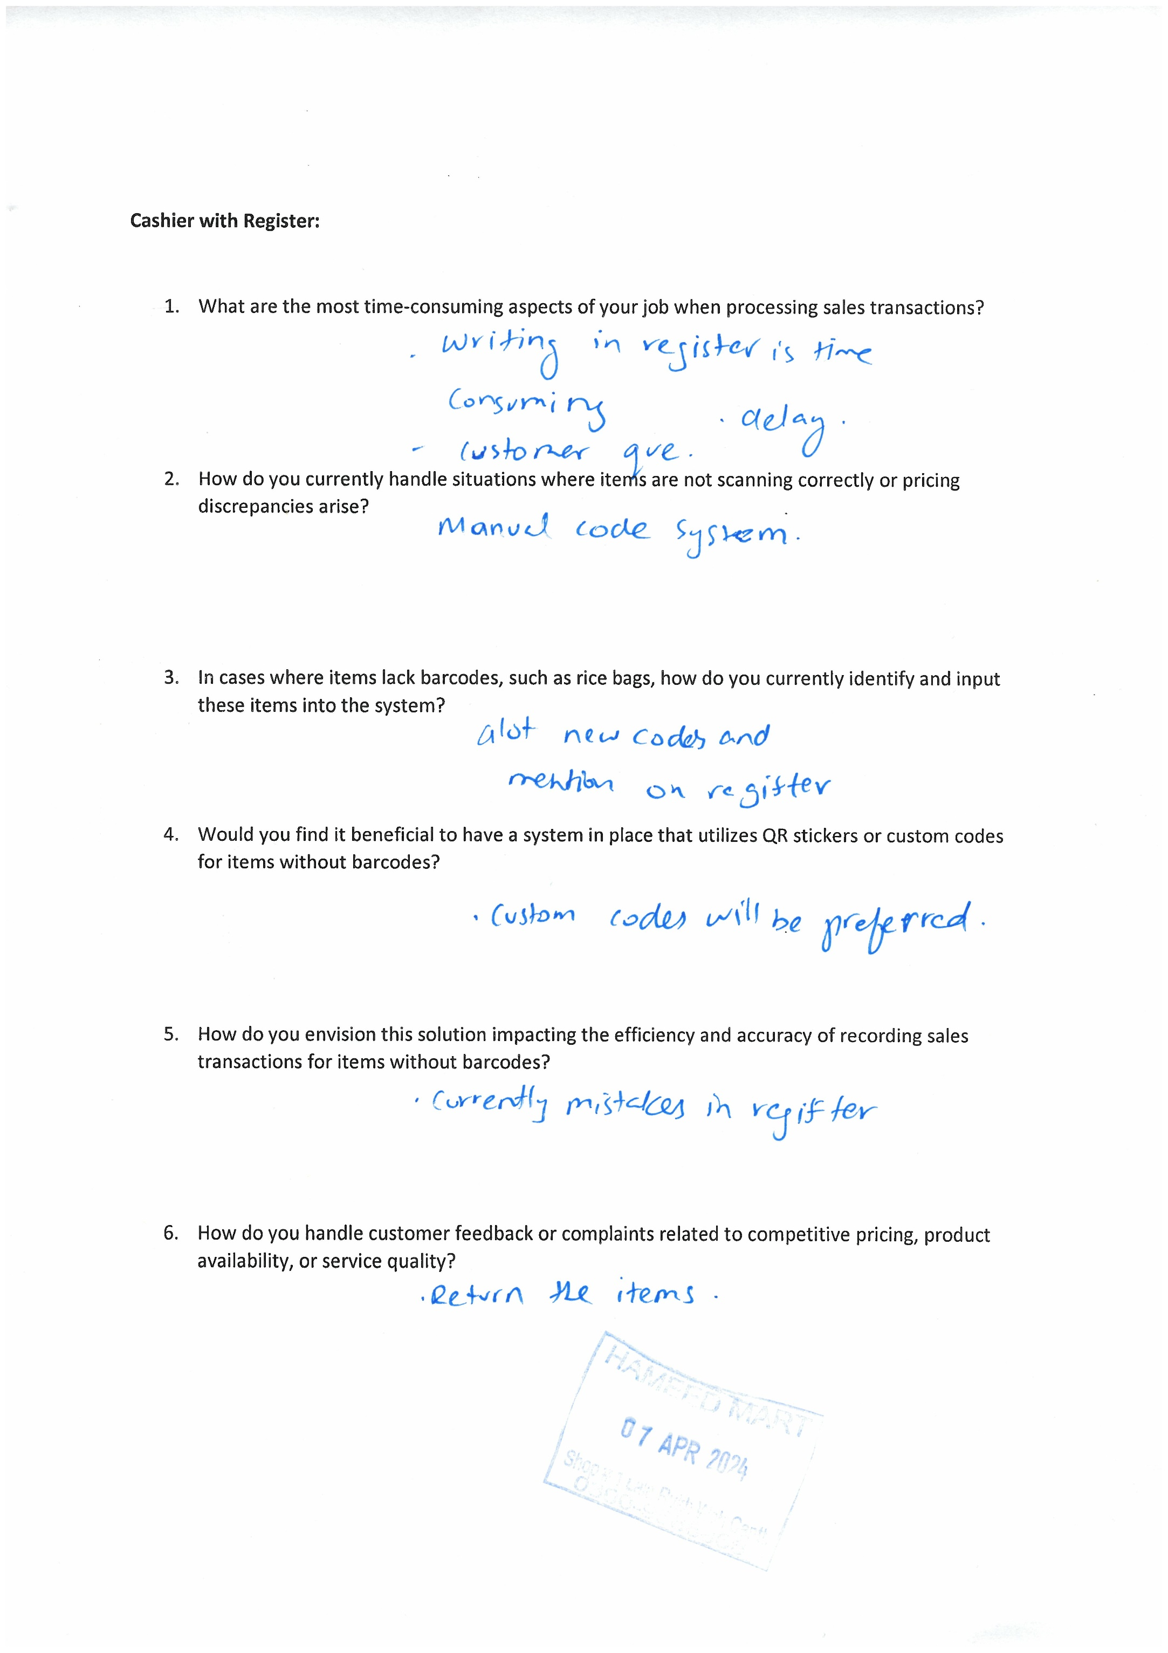

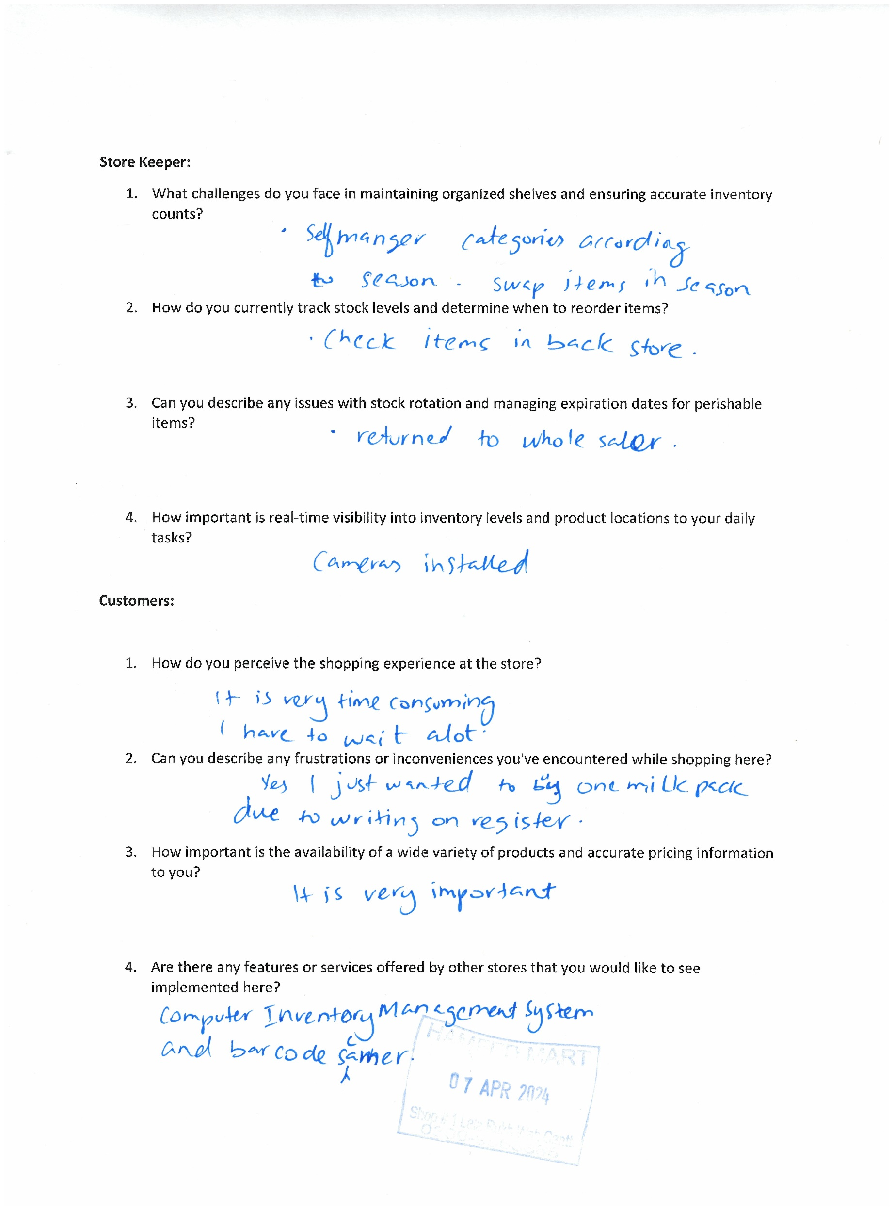

**Kariyana Store User Story and Scenario–** by Rizwan ul Hassan & Usman Aslam

Adnan is an owner of Kariyana Store in Islamabad (Near B-17) .He thinks that as today’s modern technology is advancing, he decided to upgrade his kariyana store with today’s technology. As he sees people shifting their store to online and also adding software to their stores which gives them a lot of benefits. He also think that adding software to his store will give him and client a lot of advantages. So, Adnan also want software which help him manage his products and all the information.

As the owner of the Kariyana store, he require a sophisticated information management system to oversee various aspects of his business operations effectively.

The system should provide detailed insights into the inventory, including the types of products available, their names, barcodes, descriptions, prices, stock quantities, and expiration dates if applicable. This information is crucial for inventory tracking, restocking decisions, and ensuring product availability for customers.

He need access to comprehensive supplier details, including supplier names, contact information, and the frequency and quantity of supplies received from each supplier. This data will help him maintain strong supplier relationships, track deliveries, and manage inventory efficiently.

It is essential to have a database of customer information, including customer names, contact details, and records of their previous purchases. This information will enable personalized customer interactions, targeted marketing strategies, and the development of strong customer relationships.

As the owner of the Kariyana store, he requires a system that captures detailed sales data for every transaction, including information on the items purchased, quantities, prices, and dates of purchase. Additionally, he needs to track the payment methods used, such as cash or card, and whether any discounts or promotions were applied during the transactions. This data will help him analyze sales performance, understand customer preferences, and make informed decisions to optimize revenue.

In terms of reporting needs, he was looking for the capability to generate daily, weekly, and monthly sales reports to monitor business performance and identify trends over time. Furthermore, he need alerts for low stock levels to ensure timely restocking and prevent stock outs. These reports and alerts will enable him to make data-driven decisions, manage inventory effectively, and enhance customer satisfaction by ensuring product availability.

Regarding security and access control, he need to define user roles and access levels for individuals who will use the software. It is essential to specify which users can access certain features or data based on their roles within the organization. Additionally, he may require extra security measures for specific features or sensitive data to protect confidential information and prevent unauthorized access. Implementing robust security and access control measures will safeguard the integrity of the system and ensure data privacy for the Kariyana store.

After all the information he give, then he contacted with different company and started bidding on it. In the end he got his contract with Case Dev (Our Company). Adnan sent an email to CEO of CASE dev. **(Dr. Shafaat A. Bazaz)** to see if he can recommend system for his store.

**Kariyana Store User Story Task Cards–** by Taha Malik

1. **Inventory Management Tasks:_________________________________________________**

* Enter data for each item into the inventory system.
* Maintain records of expiration dates and highlight expiring items.
* Set inventory level alerts when stock is low.

1. **Supplier Management Tasks:__________________________________________________**

* Create a database of supplier information.
* Maintain records of transactions with each supplier.
* Set up automatic notifications for new shipments.

1. **Customer Management Tasks:_________________________________________________**

* Create a customer database with contact details and previous purchase records.
* Implement a loyalty program to reward regular customers.

1. **Sales and Transaction Tasks:__________________________________________________**

* Maintain records of each transaction including item details, quantity, price, date, and payment method.
* Keep track of discounts and promotions and analyze their impact.

1. **Reporting and Analysis Tasks:_________________________________________________**

* Generate daily, weekly, and monthly sales reports.
* Analyze sales trends and identify best-selling items.

1. **Security and Access Control Tasks:_____________________________________________**

* Create user accounts and define their access levels (Admin, Staff, etc.).
* Implement data encryption and conduct regular security audits.

**2. Standard Requirement Specifications**

**2.1 Natural Language Specification-** by Muhammad Talha Ramzan

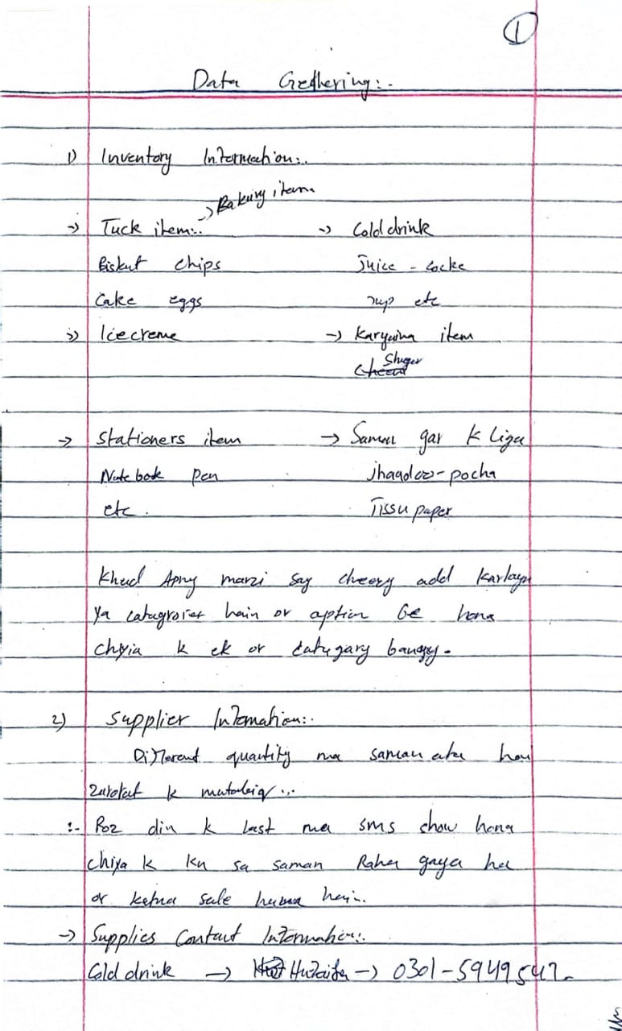

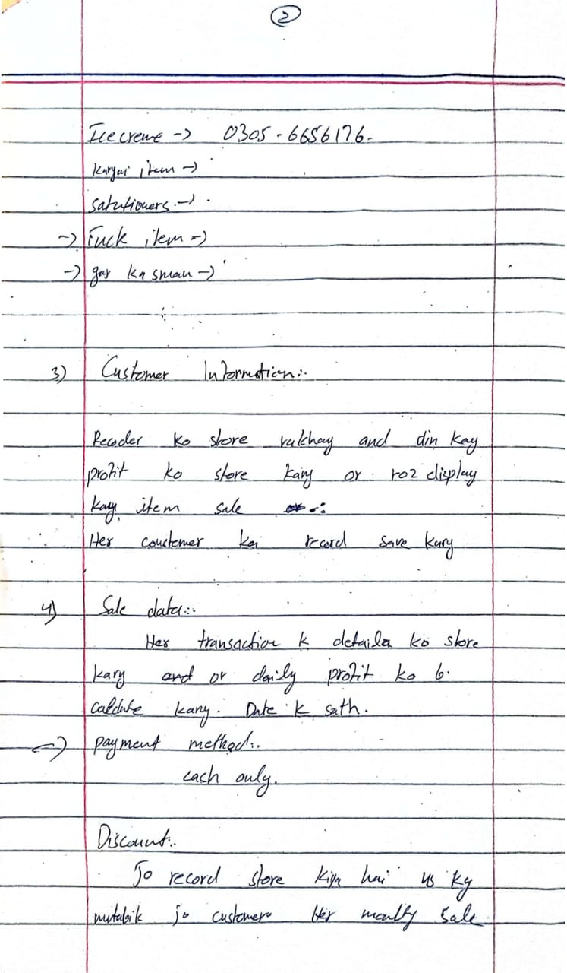

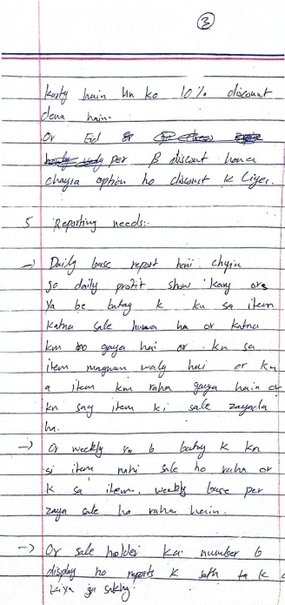

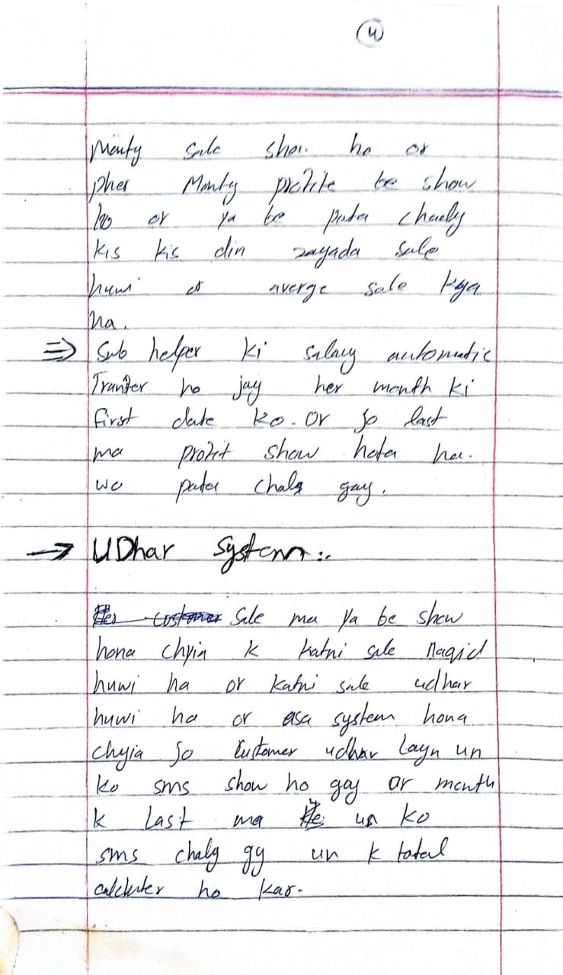

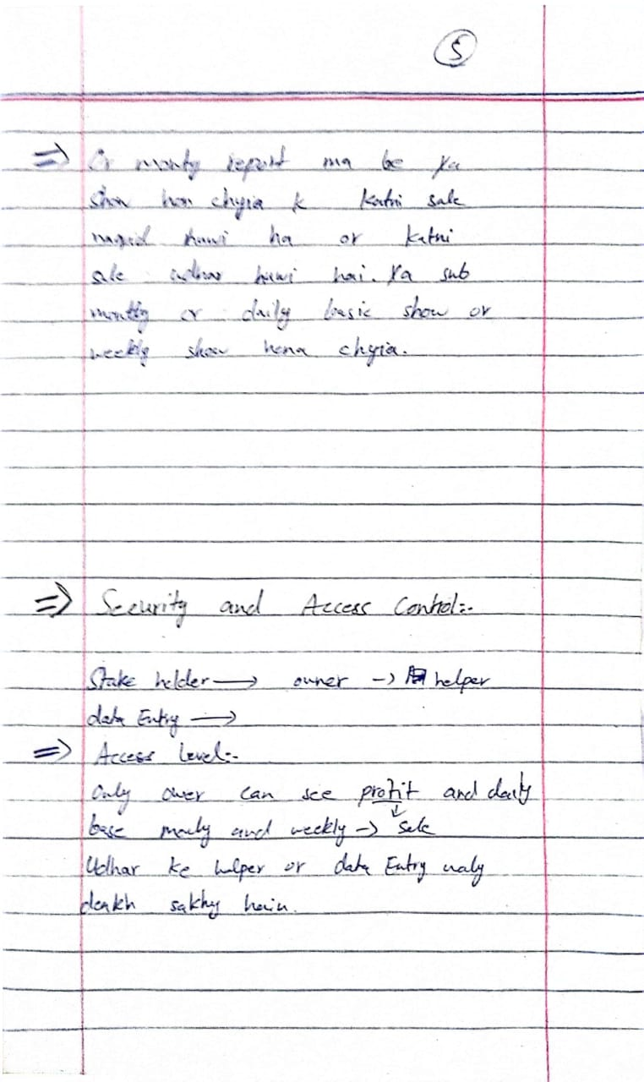

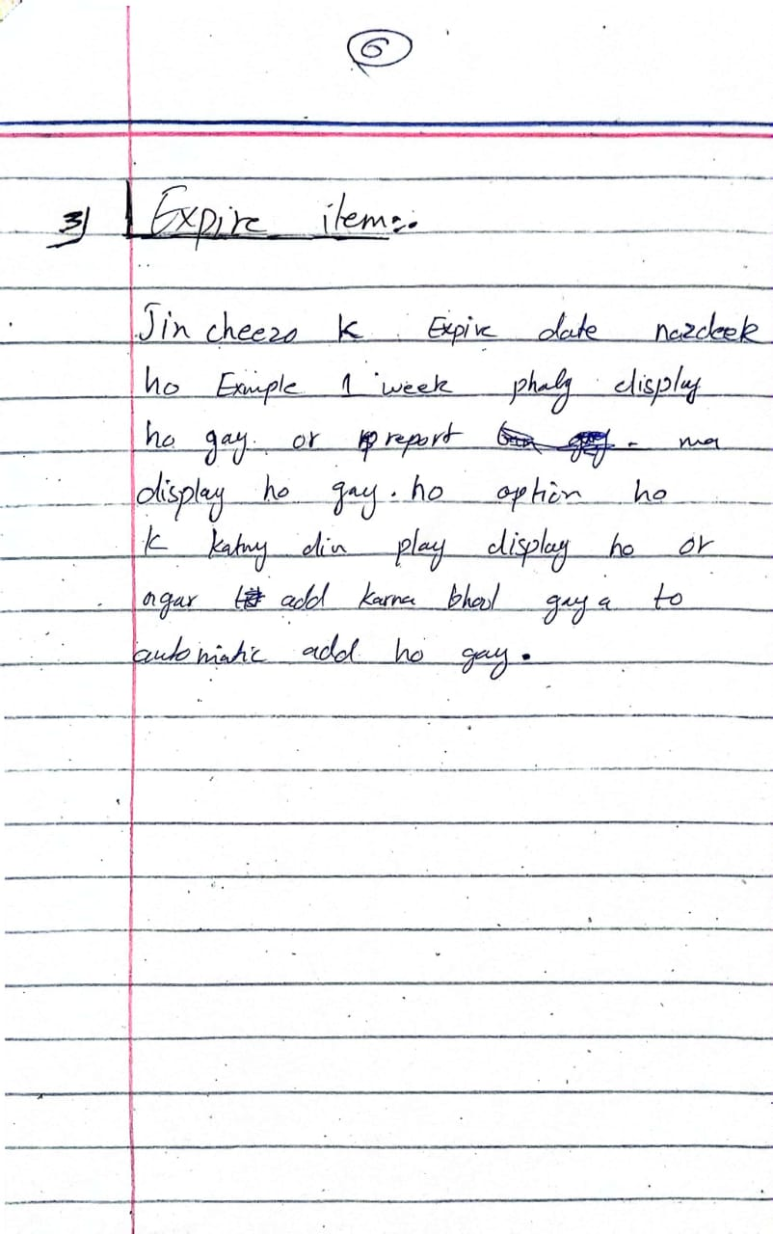

**2.2 Stakeholders Involved:**

Stake holders in this project include:

1. CEO of CASE dev. (Dr. Shafaat A. Bazaz)
2. Development team (CASE Dev.)
3. Software engineers (CASE Dev.)
4. Shop Owner(Junaid s/o Hameed)
5. Cashier(Junaid)
6. Shop store keeper(Shahbaaz)
7. Shelf planner/ manager
8. Customers
9. Whole sale Suppliers

**Structured Natural Language Specification**- by Jawad Hassan

*Kariana Mart Sales and Inventory Management System/Business Software/SRS/2.3.1*

**Function** Manage Record of Product: Inventory, Sales and Customer Information. Generate Reports and Alerts.

**Description**

The system will manage product details (types, names, barcodes, descriptions, prices, quantities, expiration dates), sales transactions (items purchased, quantities, prices, dates, payment methods), and customer information (names, contact details, purchase history). It will generate daily, weekly, and monthly sales reports and alerts for low stock levels.

**Input** Product information, sales transaction details, customer information.

**Output** Confirmation of changes, sales data, customer interaction logs, sales reports, stocklevel alerts.

**Source** User input, point of sale terminals, customer interactions and inventory monitoring.

**Destination** Database for data storage, reporting interface, alert system.

**Action**

The customer selects items from the shelves and moves to POS cash counter. Items are scanned by barcode scanner and bill is generated on thermal printer. Payment is done by customer via cash or credit card. Sales record is updated for cash received and inventory record is also updated for items sold.

**Pre-Condition**

The selected items must be available in the inventory. The system must be operational and accessible to customers.

**Post-Condition**

The customer's bill is paid, and the transaction is completed. Sales records are updated to reflect the transaction. The inventory record is updated to deduct the selected items.

**User and System Requirements**

User Requirement Definition

|  |
| --- |
| 1. The system shall Manage Record of Product: Inventory, Sales and Customer Information. Generate Reports and Alerts. |

System Requirement Specification

|  |
| --- |
| * 1. The system must be able to maintain real time records of products in inventory, including details such as quantity, location, and status.   2. The system should track sales transactions, including date, time, products sold and customer information, to maintain an accurate record of sales.   3. The system should store and manage customer information, such as contact details, purchase history, and preferences, to facilitate personalized customer service.   4. The system should generate various reports, such as inventory status, sales performance, and customer analytics, to provide insights for decision-making.   5. The system should be able to generate alerts for low inventory levels, high sales volume, or other relevant events, to help in proactive management of the business.   6. Top of Form |

Flowchart by Adil Khan

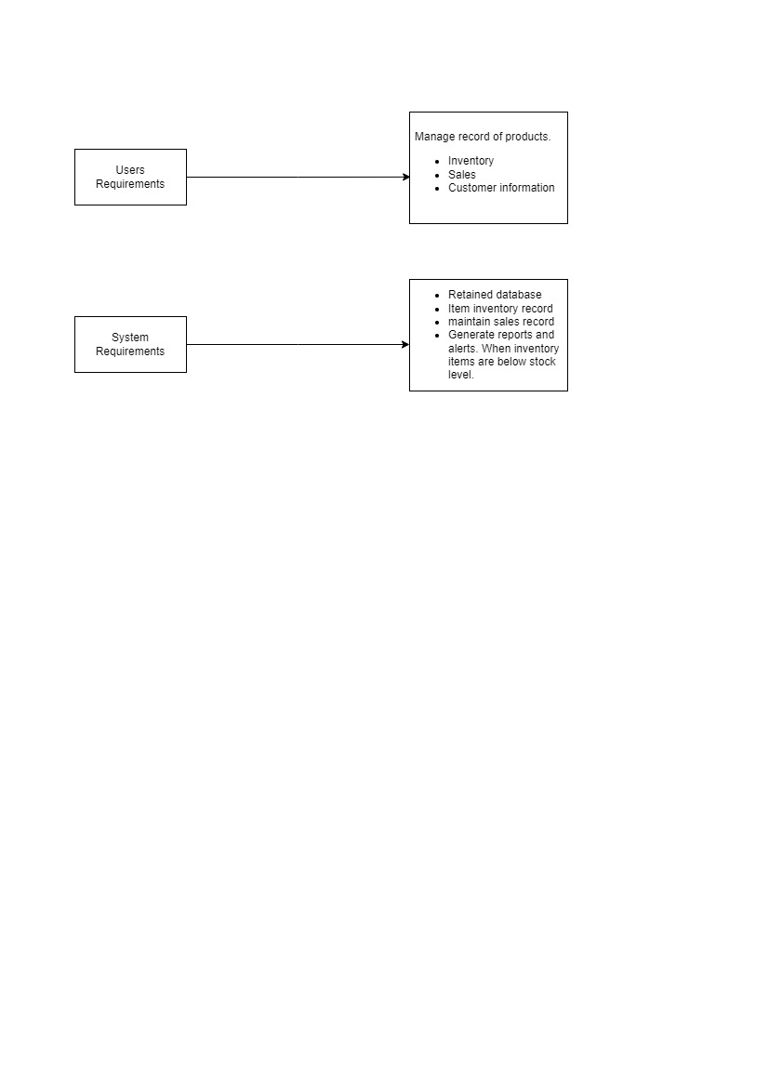

**Functional Requirements**

**Inventory Management:**

* + The system shall provide functionality to manage:
    - Product types
    - Names
    - Barcodes
    - Descriptions
    - Prices
    - Stock quantities
    - Expiration dates (if applicable).
  + Searching And Tracking
    - Inventory tracking
    - Restocking decisions
    - Ensuring product availability.

**Supplier Management:**

* + The system shall allow for the management of:
    - Supplier details including names, contact information, and details of supplies received.
    - Tracking deliveries, maintaining supplier relationships, and efficient inventory management.

**Customer Management:**

* + The system shall include features for:
    - Storing customer information such as names, contact details, and purchase history.
    - Personalized customer interactions, targeted marketing, and building strong customer relationships.

**Sales Data Management:**

* + The system shall capture and manage:
    - Detailed sales data for each transaction including items purchased, quantities, prices, dates, and payment methods.
    - Analysis of sales performance and understanding customer preferences.

**Reporting and Alerts:**

* + The system shall generate:
    - Daily, weekly, and monthly sales reports to monitor business performance and trends.
    - Alerts for low stock levels to facilitate timely restocking and prevent stock outs.

**Non Functional** **Requirements**

**Security and Access Control:**

* + The system shall implement:
    - User authentication mechanisms with role-based access control.
    - Encryption for sensitive data transmission and storage.
    - Measures to prevent unauthorized access and ensure data privacy.

**Performance:**

* + The system shall ensure:
    - Fast response times for user interactions and data retrieval.
    - Scalability to handle increasing data and user loads over time.

**Reliability:**

* + The system shall be:
    - Highly available, with minimal downtime for maintenance or upgrades.
    - Capable of recovering from failures gracefully without data loss.

**Usability:**

* + The system shall provide:
    - Intuitive user interfaces for ease of use.
    - Clear navigation and informative feedback to users.

**Compatibility:**

* + The system shall be compatible with:
    - Various web browsers and operating systems commonly used by the target users.
    - Integration with existing hardware and software systems, if applicable.

**Scalability:**

* + The system shall be designed to:
    - Accommodate growth in data volume and user base without significant performance degradation.
    - Scale resources horizontally or vertically as needed to meet demand.

**Maintainability:**

* + The system shall be:
    - Well-documented with clear code structure and comments.
    - Modularized to facilitate updates, bug fixes, and enhancements.

**Required Hardware Equipment**

To run this software we need following hardware equipment:

1. Computer (PC):
   1. Processor: Intel Core i5 or equivalent
   2. RAM: 8GB or higher
   3. Storage: 256GB SSD or higher
   4. Operating System: Windows 10 or higher
2. Barcode Scanner:
   1. Type: USB-connected handheld or desktop scanner
   2. Compatibility: Should be compatible with Windows
   3. Resolution: Minimum 1D/2D barcode scanning capability
3. Thermal Printer:
   1. Type: USB-connected thermal receipt printer
   2. Compatibility: Should be compatible with Windows
   3. Print Speed: 150 mm/s or higher
   4. Paper Size: 80mm width for standard receipt printing
4. Monitor:
   1. Size: 21 inches or larger
   2. Resolution: Full HD (1920 x 1080) or higher
   3. Keyboard and Mouse:
   4. Standard USB or wireless keyboard and mouse
5. Barcode Labels and Receipt Paper:
   1. Purchase barcode labels compatible with the barcode scanner
   2. Purchase thermal paper rolls compatible with the thermal printer
6. Cash Drawer:
   1. USB-connected cash drawer
7. Customer Display:
   1. USB-connected customer display for showing transaction details

**Test Cases**

1. **Inventory Management:**

* Test Case 1: Verify that the software can add a new product to the inventory.
  + Test Case 2: Verify that the software can update the quantity of a product in the inventory.
  + Test Case 3: Verify that the software can delete a product from the inventory.
  + Test Case 4: Verify that the software can generate a report of current inventory levels.

1. **Sales Management:**
   * Test Case 5: Verify that the software can add a new sale transaction.
   * Test Case 6: Verify that the software can update the details of a sale transaction.
   * Test Case 7: Verify that the software can delete a sale transaction.
   * Test Case 8: Verify that the software can generate a report of daily sales.

**Mathematical specifications**

Basic formulas for inventory, sales, and profit calculations:

|  |  |
| --- | --- |
| **Category** | **Formula** |
| Inventory | Ending Inventory=Beginning Inventory + Purchases - Sales |
| Sales | Sales = Quantity Sold * Price per Unit |
| Profit | Profit = (Sales - Cost of Goods Sold) - Expenses |

**Non-Functional Requirement Specification in Tabular Form**

|  |  |
| --- | --- |
| **Non-Functional Requirement** | **Figure of Merit** |
| Security and Access Control | Authentication success rate  Authorization response time  Number of failed login attempts per unit time |
| Performance | Transactions per second (TPS)  Response time for user interactions  Server throughput  CPU and memory utilization under load |
| Reliability | Mean Time Between Failures (MTBF)  Mean Time To Failure (MTTF)  Mean Time To Repair (MTTR)  Percentage of uptime |
| Usability | User satisfaction score (e.g., through surveys)  Time to complete common tasks  Error rates during user interactions |
| Compatibility | Compatibility with various browsers and operating systems  Integration with external systems without errors  Conformance to industry standards |
| Scalability | Scalability factor (e.g., ratio of performance increase with increased resources)  Response time under varying loads  Ability to handle increasing data volume |
| Maintainability | Mean Time To Repair (MTTR)  Code complexity metrics (e.g., Cyclomatic Complexity)  Percentage of code covered by automated tests  Average time to implement changes or updates |

**Graphical Notations**

**Use Case UML Diagram-** by Adil Khan

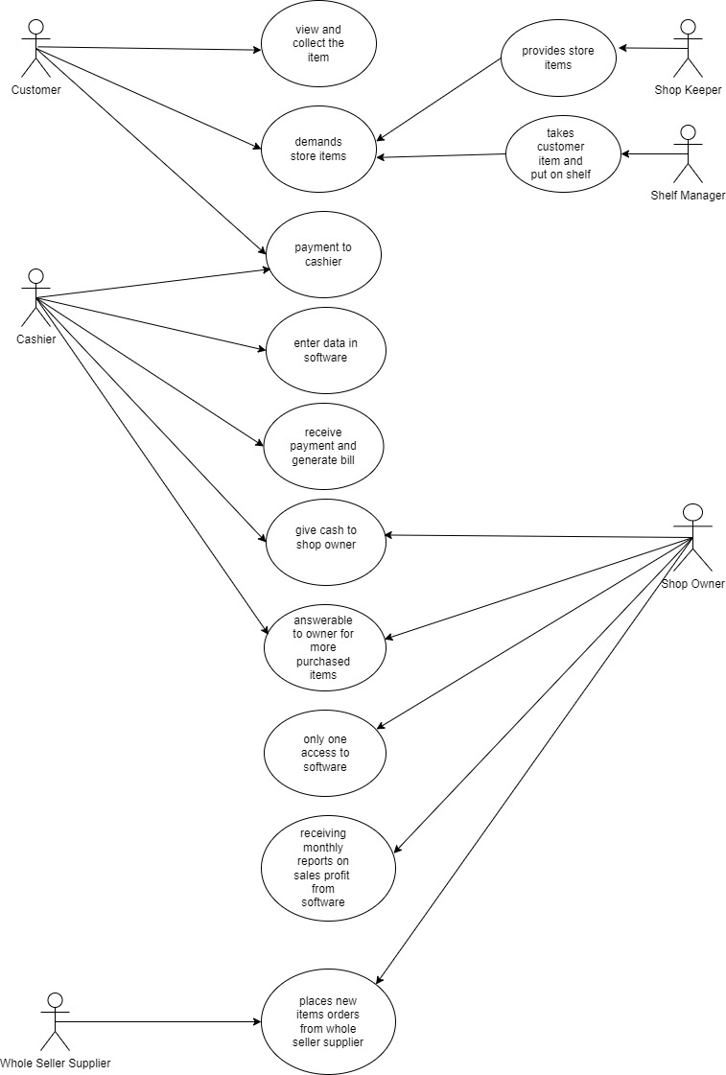

**UML Diagram of Software System:**

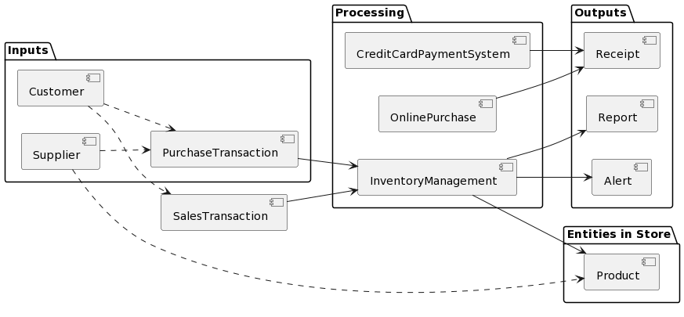

**Flowcharts**

|  |  |
| --- | --- |
| Purchase and sale in a karyana store are in a continuous loop: |  |

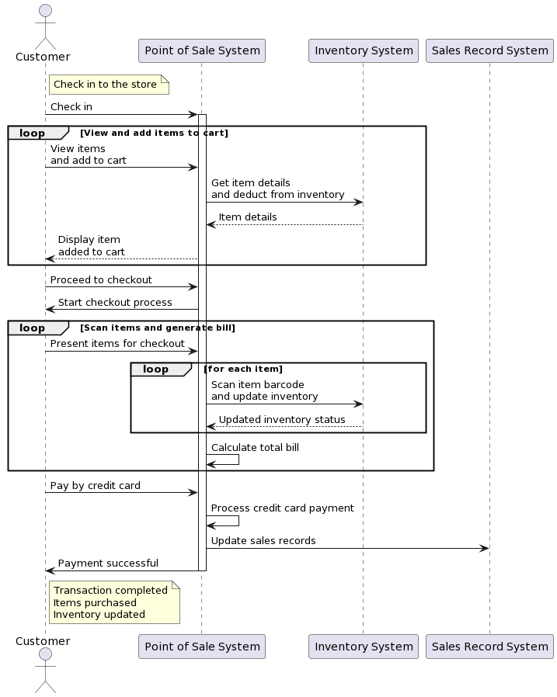

**Requirement Validation Approval Letter**

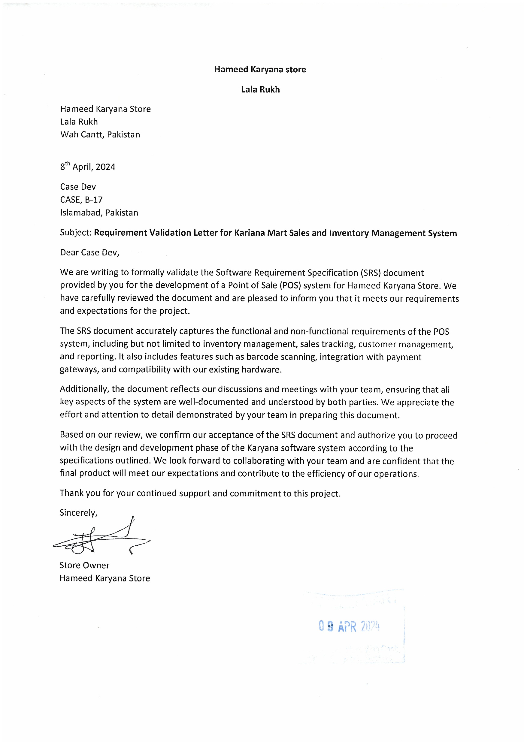

Index

Barcode Scanning**19**

FMCG (Fast-Moving Consumer Goods)**15**

Inventory Management**25**

Point of Sale (POS)3**1**

Test cases**35**

User Story**24**

UML (Unified Modeling Language)**37**

User Interface Design**34**